**Forecasting Future Sales**

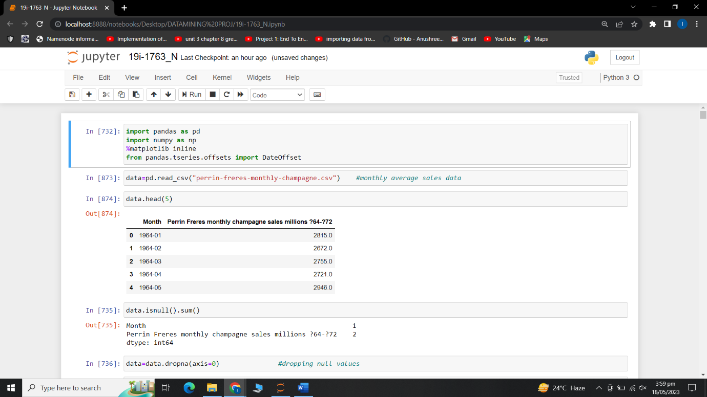

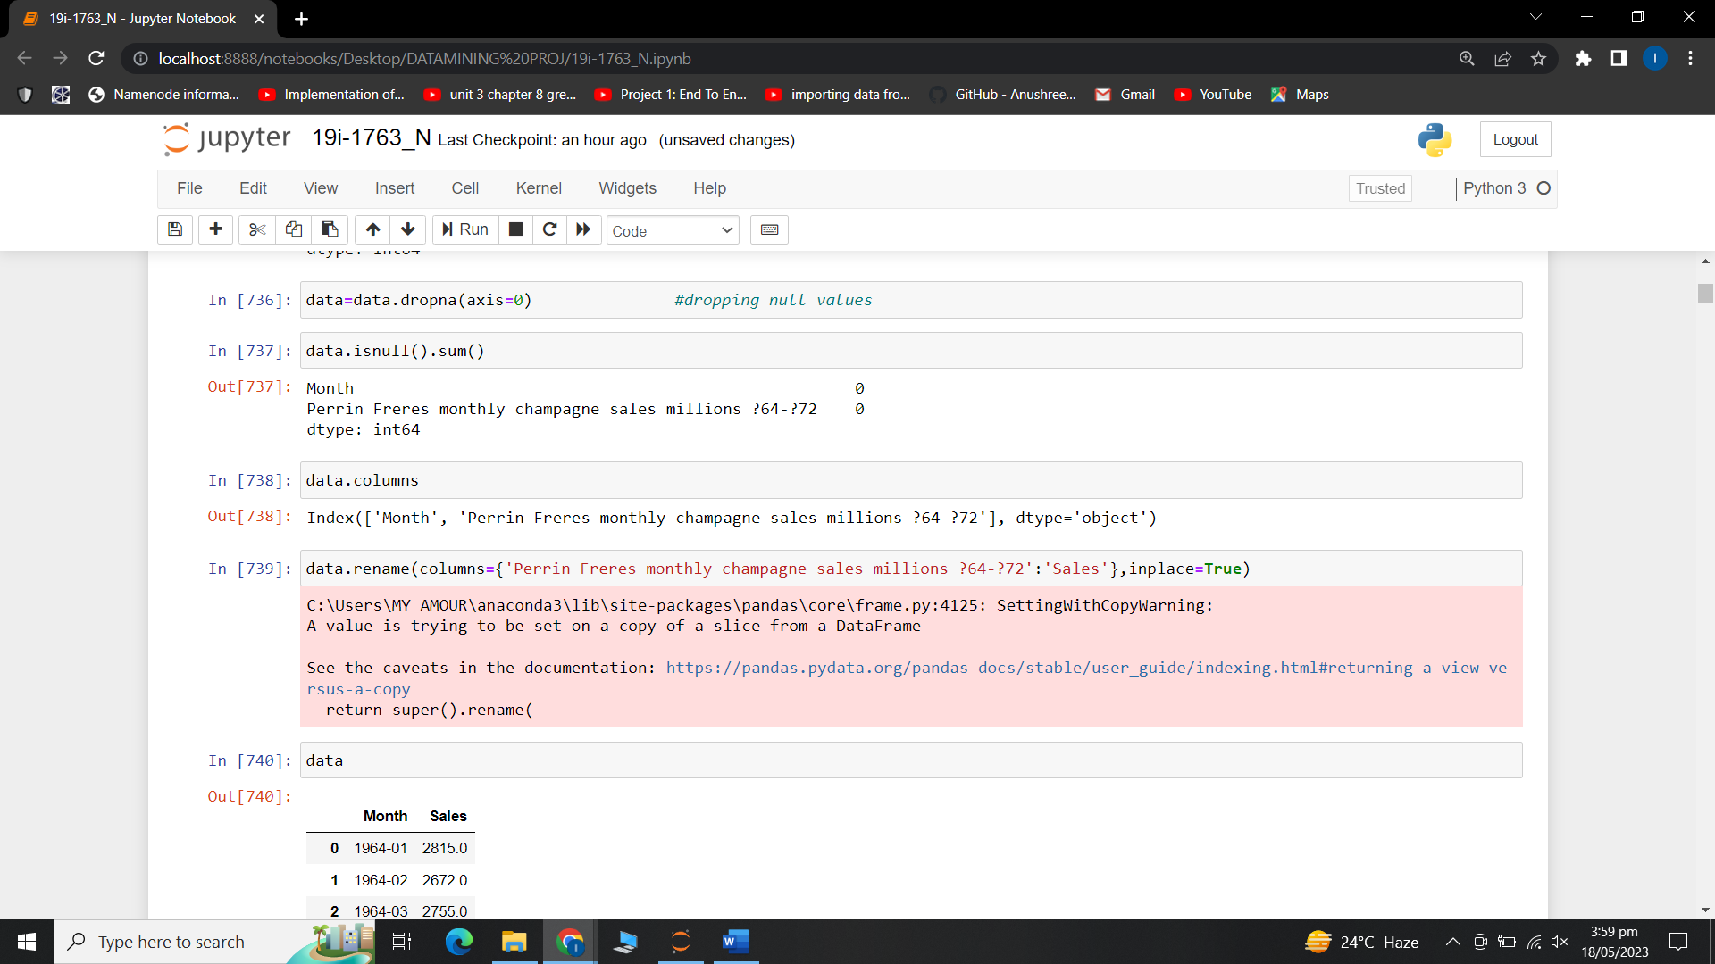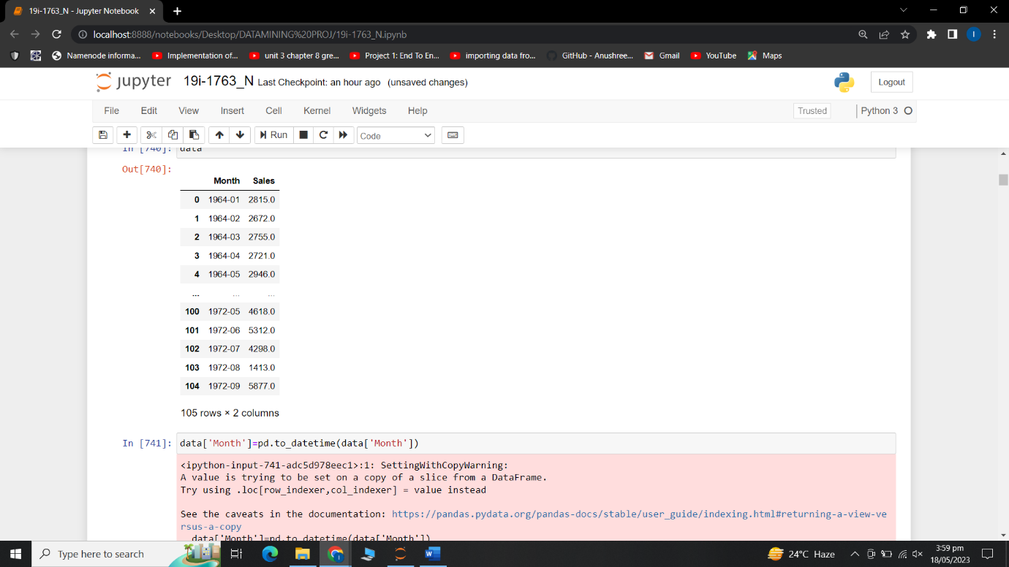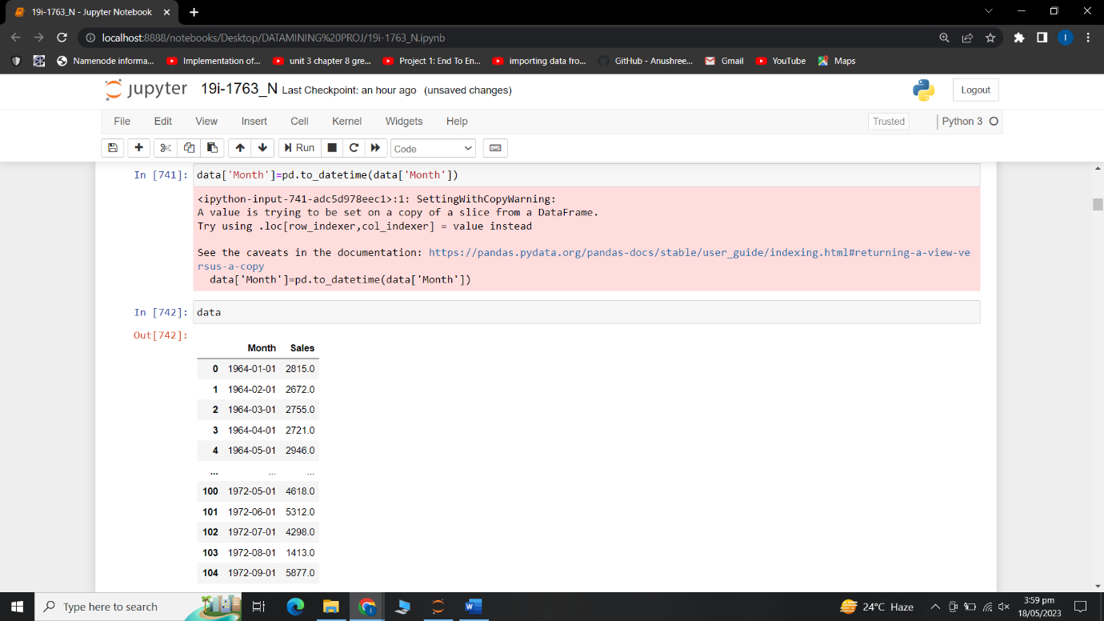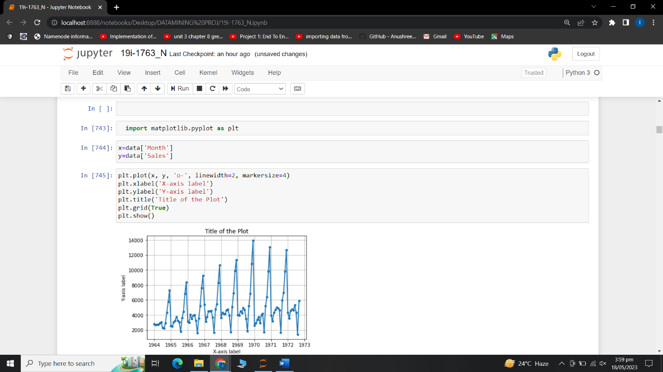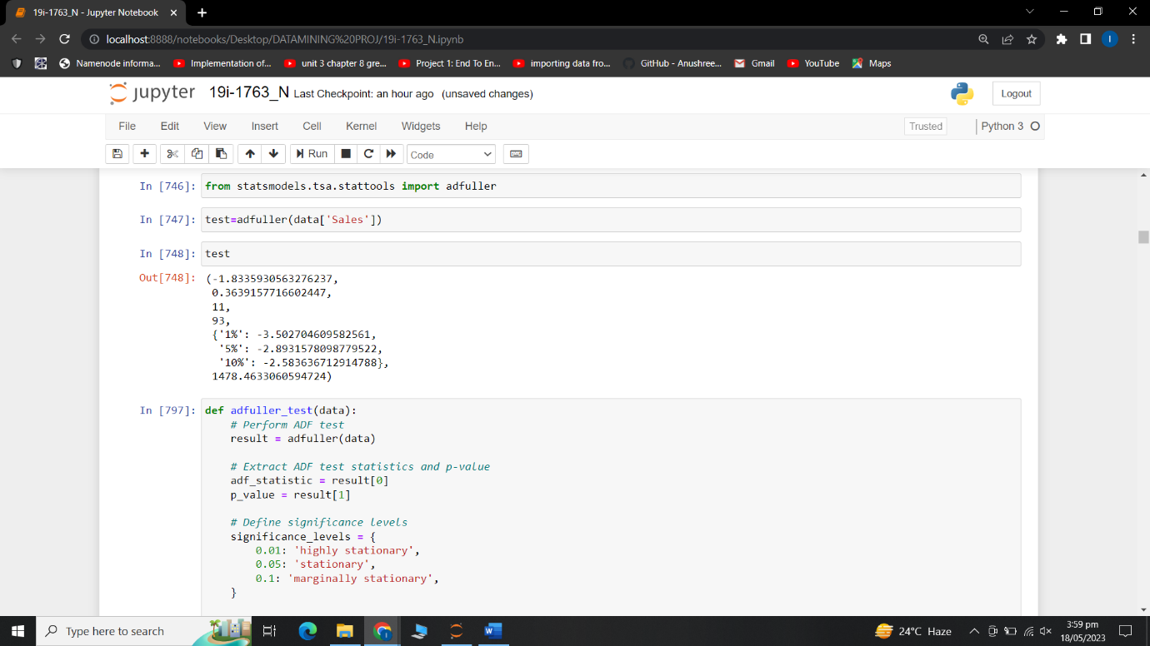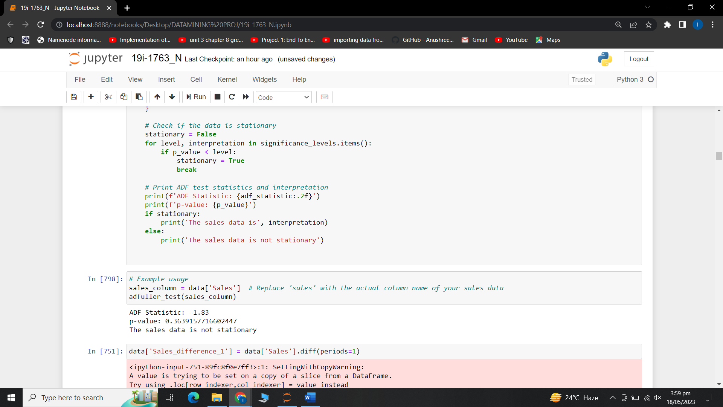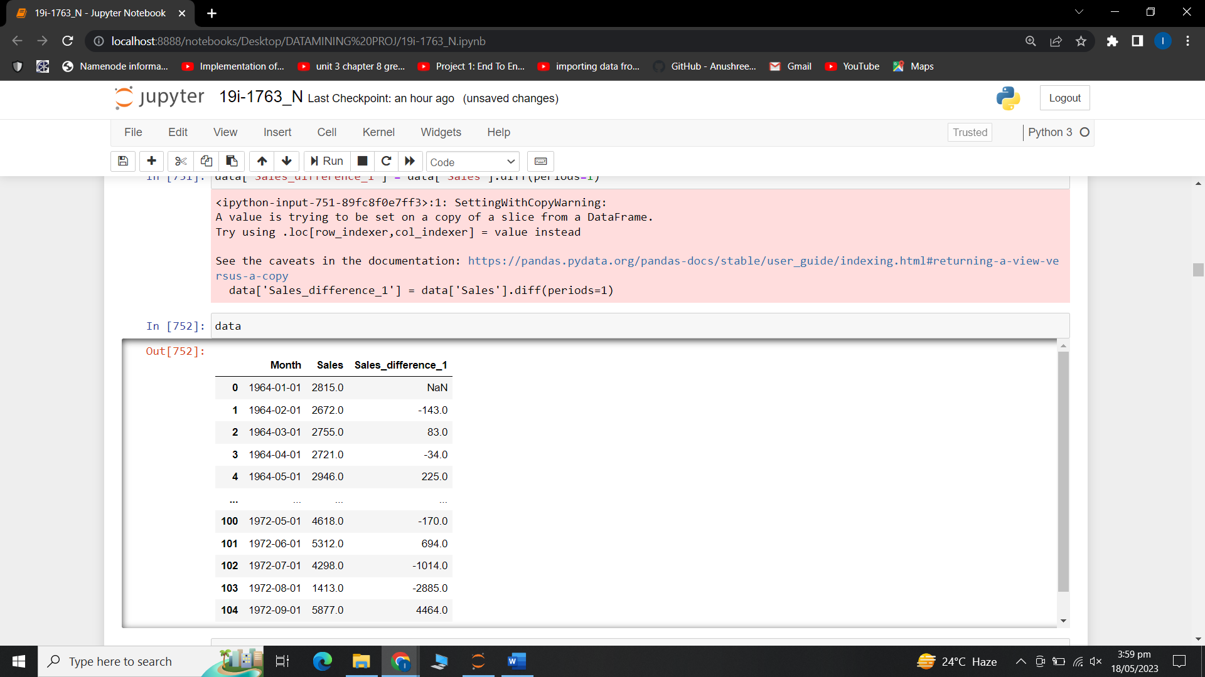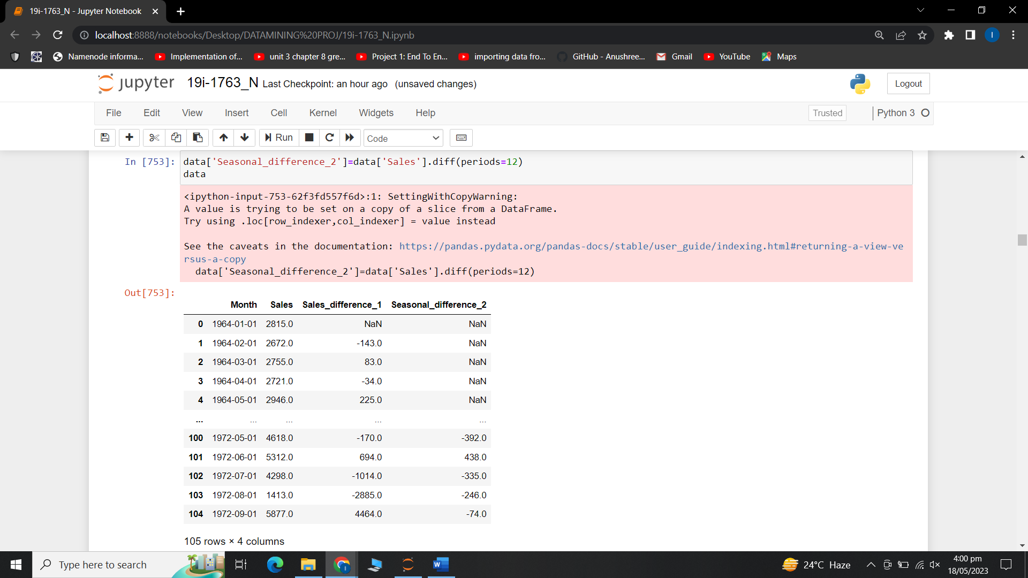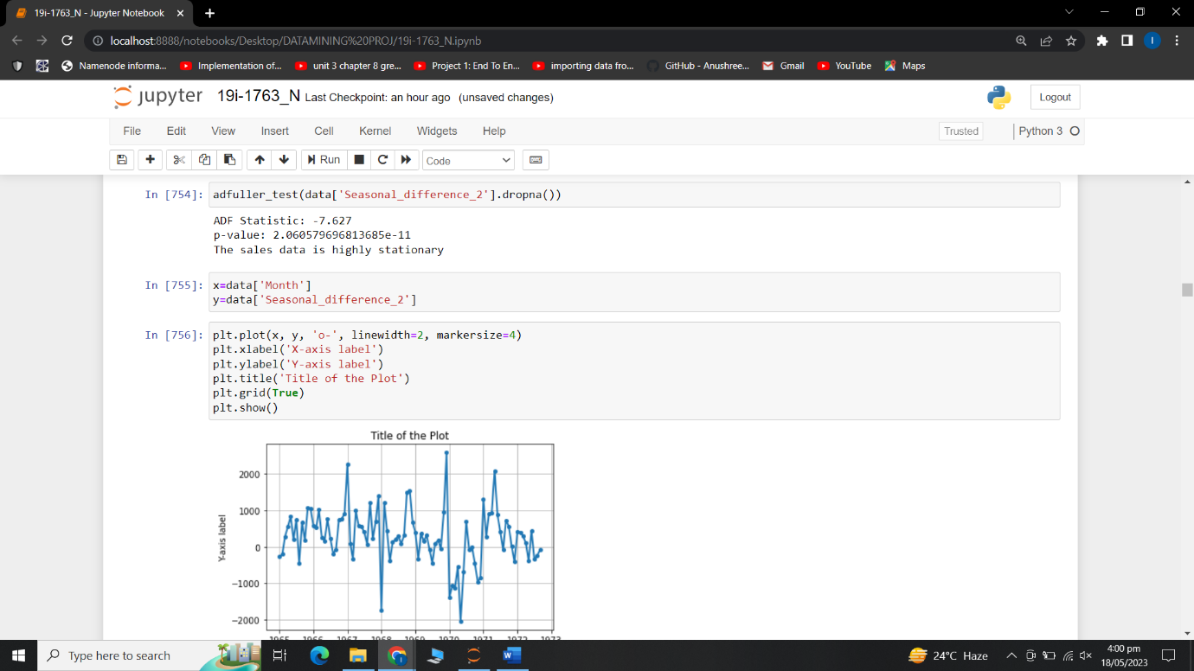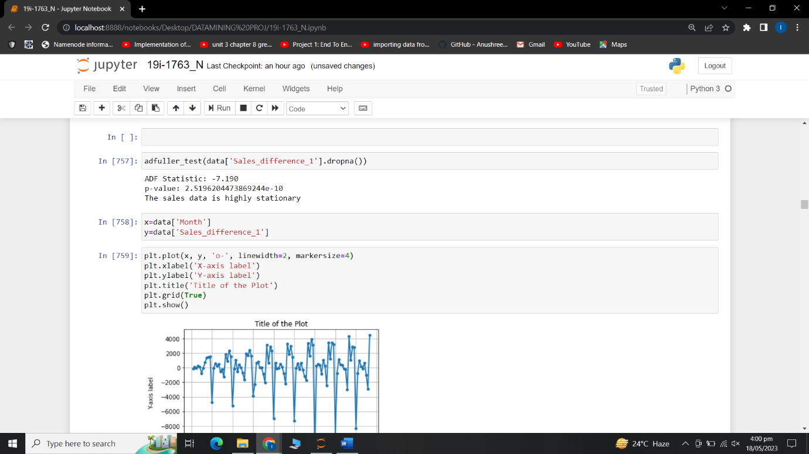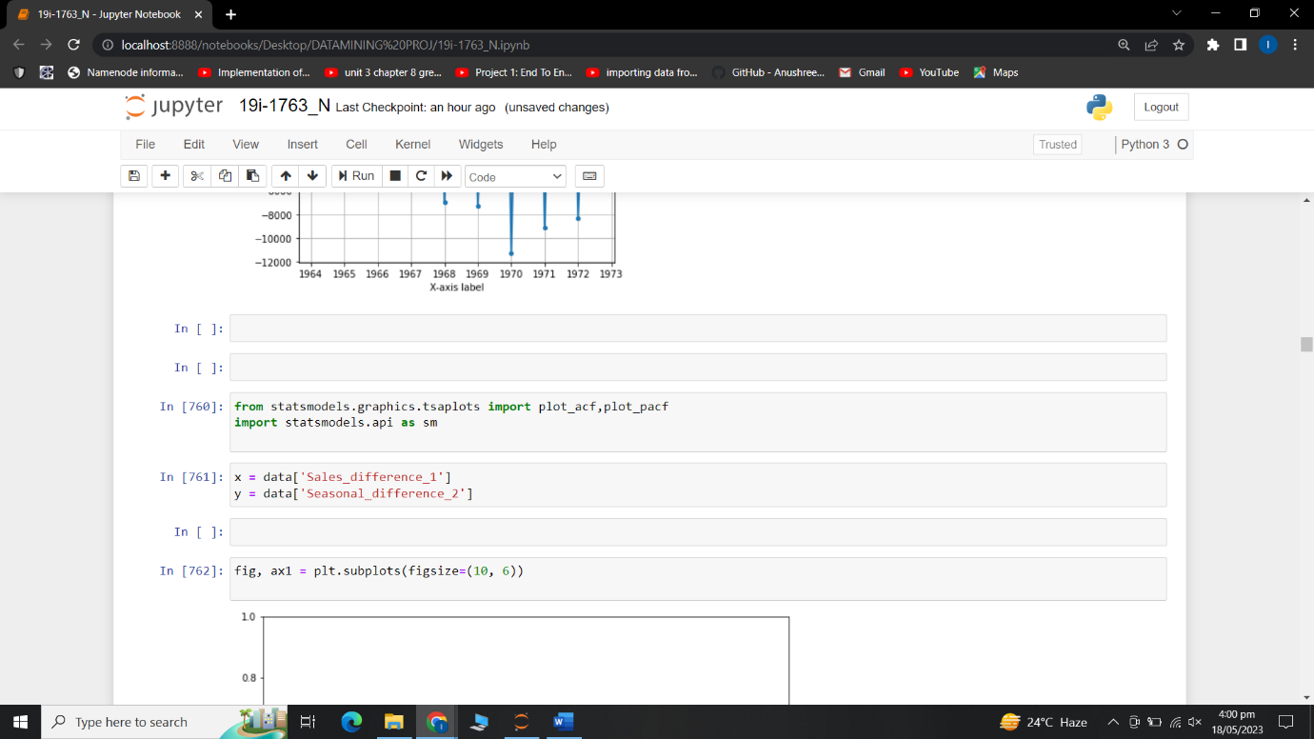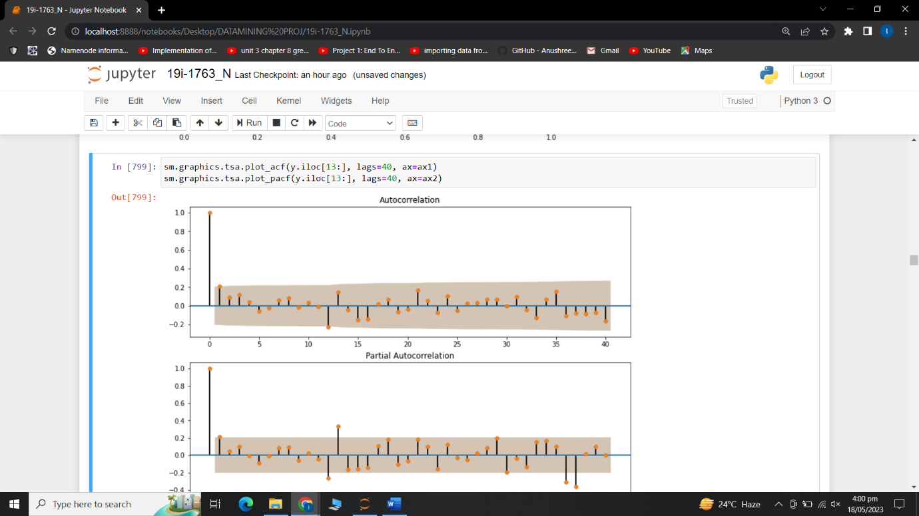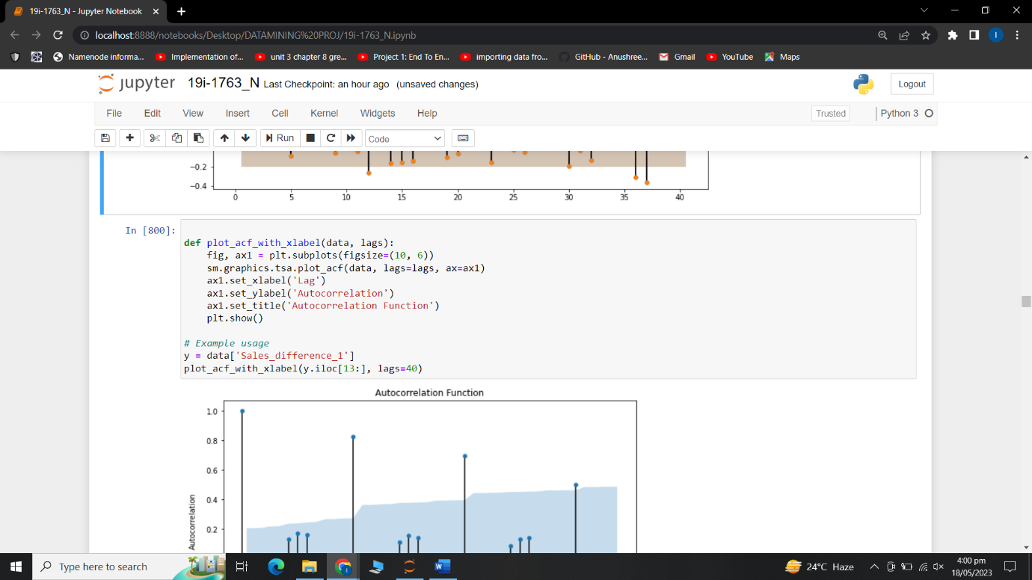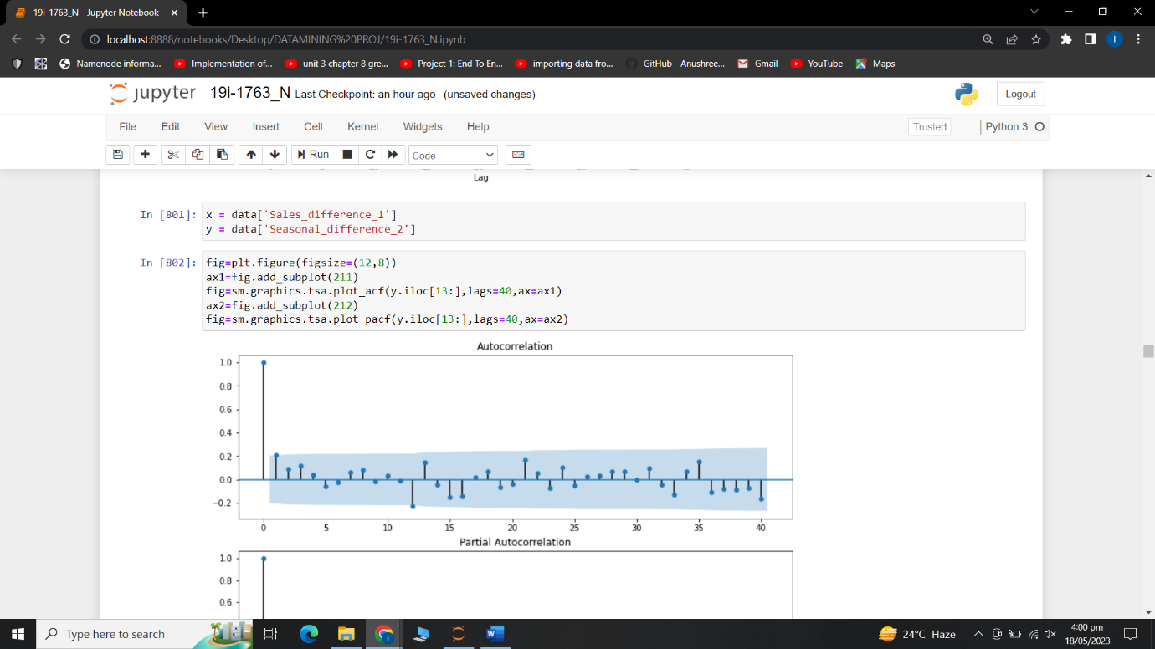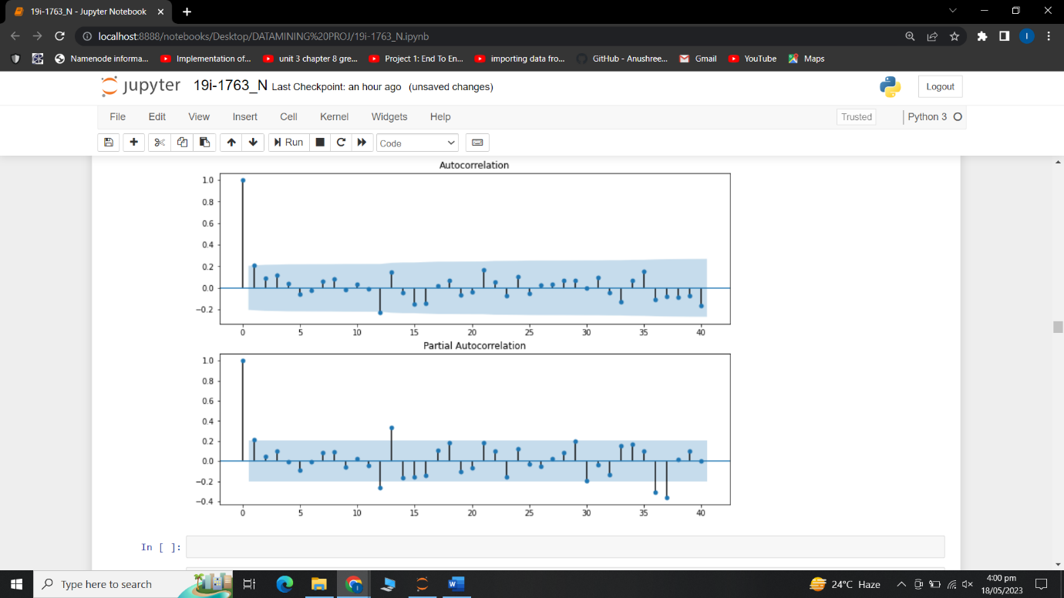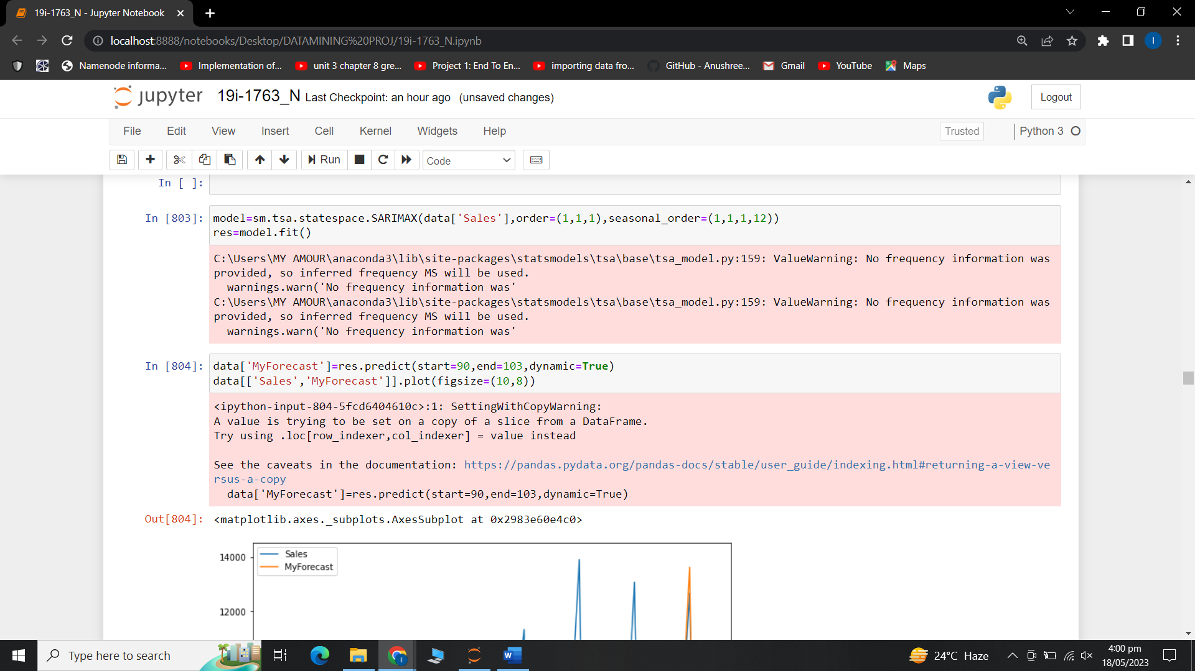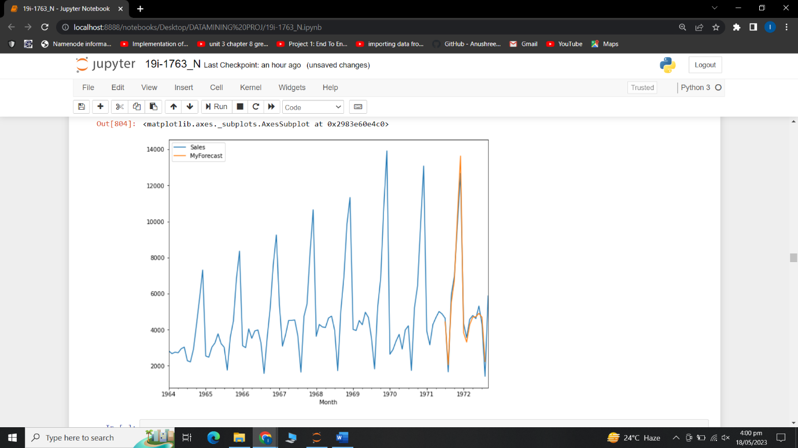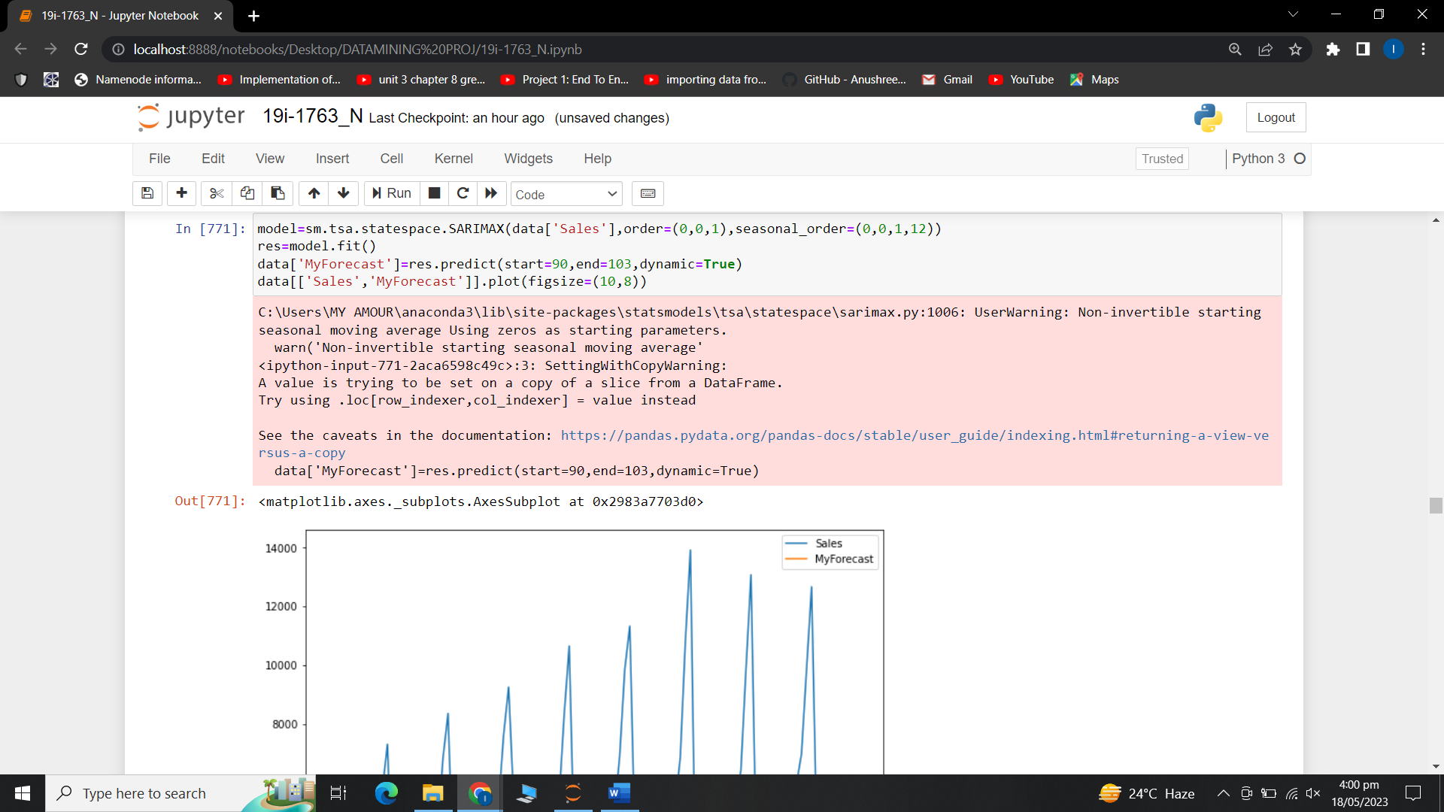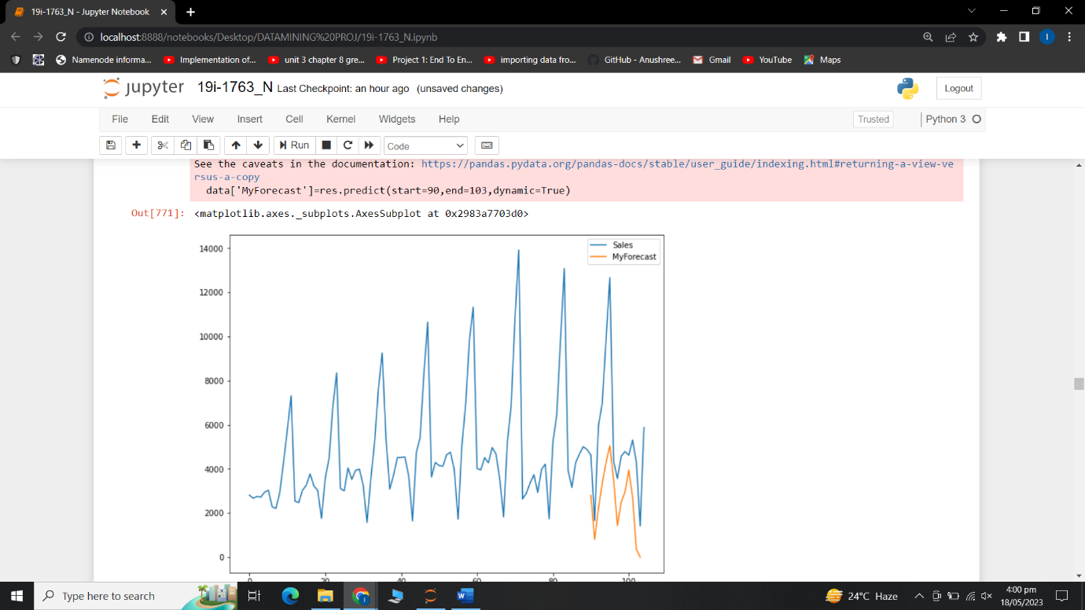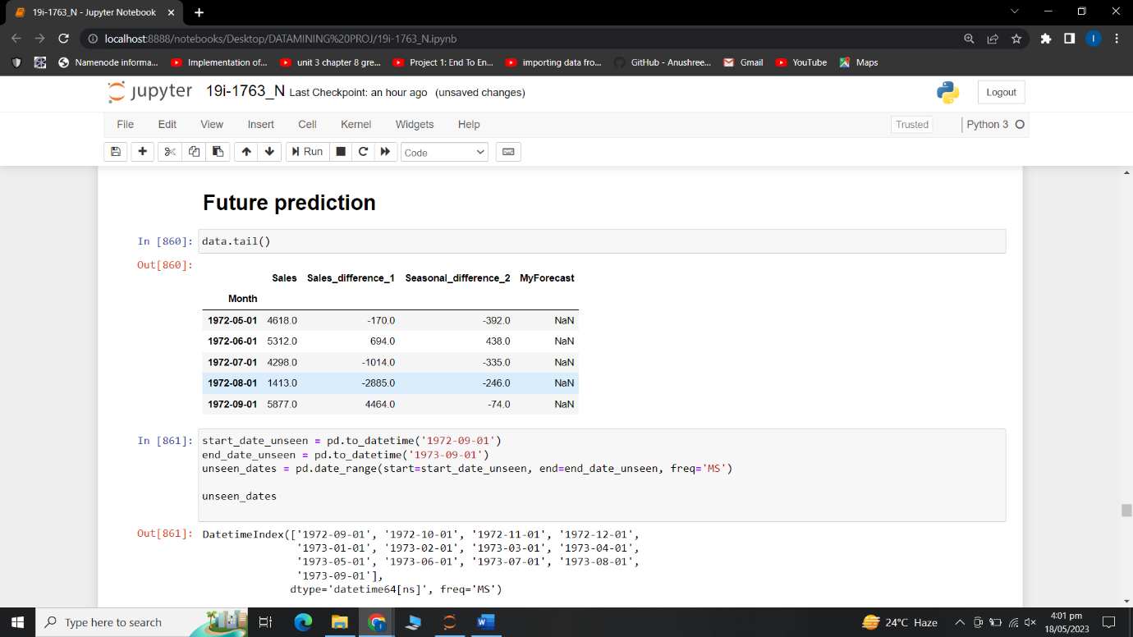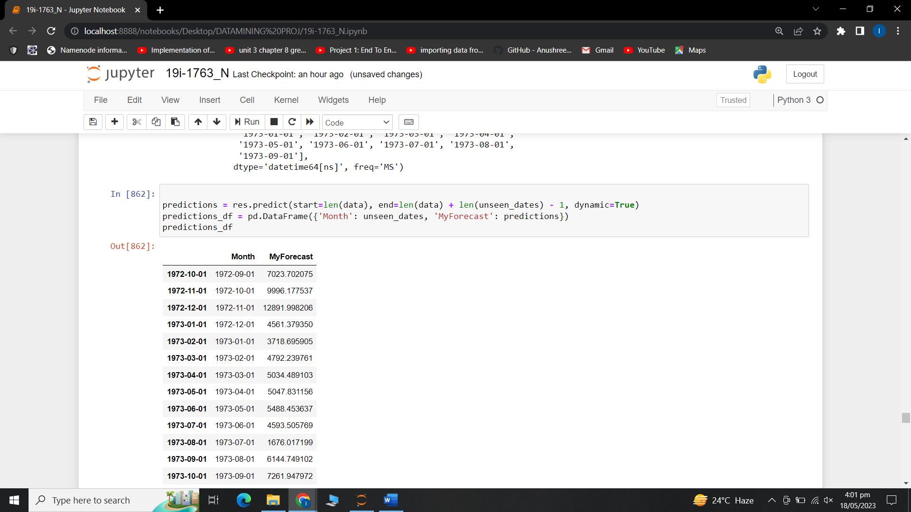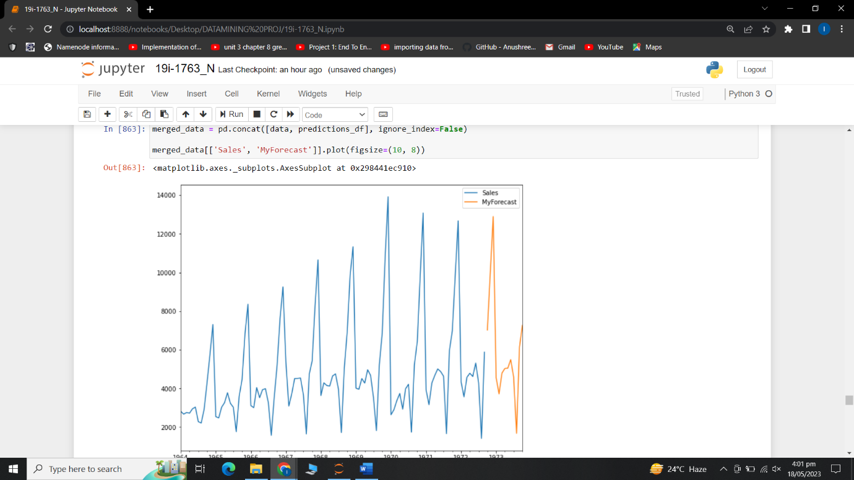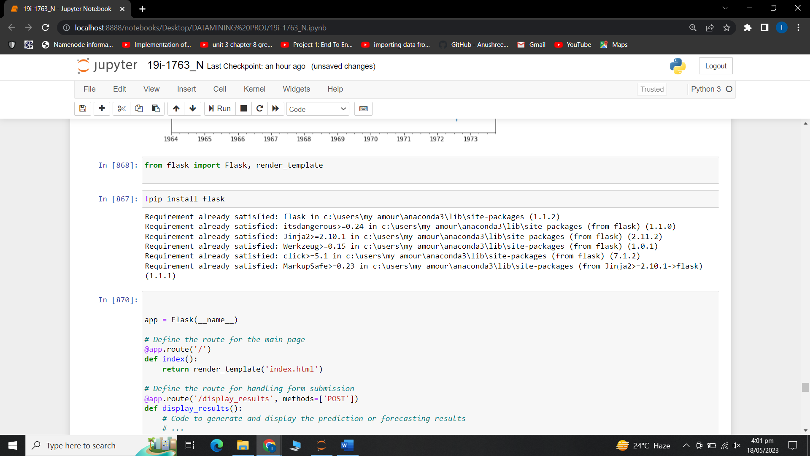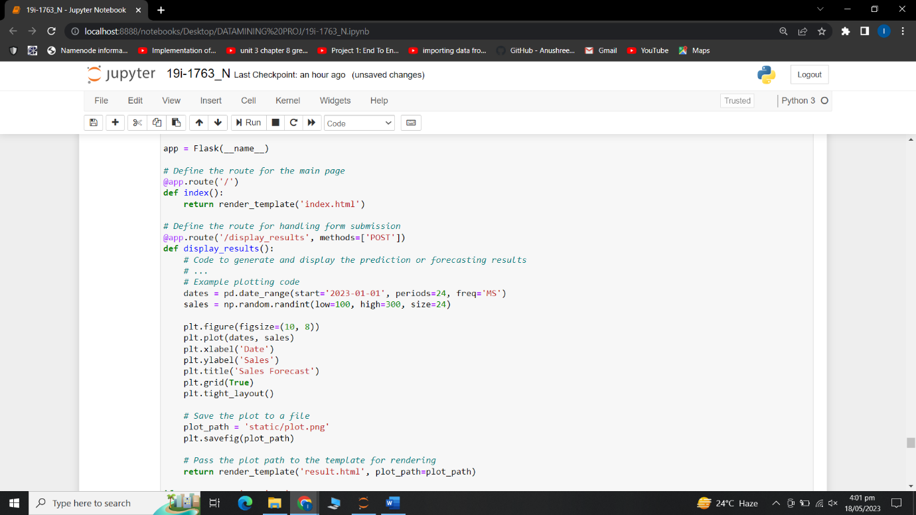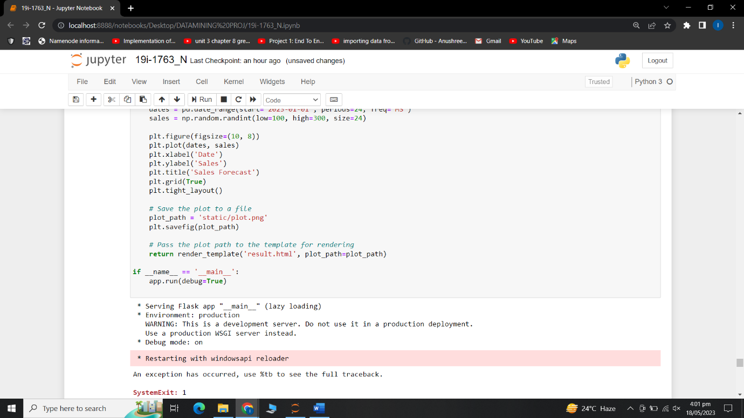  
Time Series Analysis with the ARIMA model, specifically SARIMAX, which stands for Seasonal AutoRegressive Integrated Moving Average with eXogenous regressors, to predict sales data. Below is a detailed explanation of each part of the script.

**Libraries and Data Loading**:

The code starts by importing necessary libraries for data analysis and visualization. It then reads sales data from a CSV file. After loading the data, it renames a column to 'Sales' for easier referencing and changes the 'Month' column to a DateTime format for time series analysis.

**Data Plotting:**

The sales data is plotted using matplotlib. The data is represented in a scatter plot with the 'Month' on the x-axis and 'Sales' on the y-axis.

**Augmented Dickey-Fuller (ADF) Test:**

The ADF test is performed to check the stationarity of the data. Stationarity is an important concept in time series analysis, and it means that the statistical properties of a series (mean, variance, covariance) do not change over time. The test results are interpreted at various significance levels.

**Differencing**:

The data is transformed to make it stationary if it's not already. This is done by differencing, where the difference between consecutive observations is calculated. Two different differences are calculated, a simple difference between consecutive sales, and a seasonal difference (which in this case is based on 12 months).

Autocorrelation and Partial Autocorrelation: The Autocorrelation Function (ACF) and Partial Autocorrelation Function (PACF) are plotted to identify potential parameters for the ARIMA model.

**SARIMAX Model:**

Both SARIMA (Seasonal Autoregressive Integrated Moving Average) and ARIMA (Autoregressive Integrated Moving Average) models are time series models used for forecasting and analyzing time-dependent data.

**ARIMA Model:**

The ARIMA model is a generalized form of the autoregressive (AR) and moving average (MA) models. It is typically used for non-seasonal time series data, where there is no clear pattern of seasonality. The ARIMA model takes into account three main components: autoregressive (AR), differencing (I), and moving average (MA).

Autoregressive (AR): The AR component models the relationship between an observation and a number of lagged observations from the past.

Differencing (I): The differencing component is used to remove any trend or seasonality from the data by differencing the observations.

Moving Average (MA): The MA component models the dependency between an observation and a residual error from a moving average model applied to lagged observations.

ARIMA models are suitable for forecasting data that does not exhibit clear seasonal patterns, such as stock prices, population growth, or temperature fluctuations.

**SARIMA Model:**

The SARIMA model extends the ARIMA model to include seasonal components. It is used when the time series data exhibits clear seasonal patterns. In addition to the ARIMA components, SARIMA models also include seasonal differencing and seasonal autoregressive and moving average terms.

SARIMA models capture both the non-seasonal and seasonal components of the data and are useful for forecasting and analyzing data with significant seasonal variations, such as monthly sales data, quarterly revenue, or annual temperature patterns.

**Predictions:**

Sales are predicted based on the SARIMAX model for a certain time period in the past (from the 90th to the 103rd month). The actual sales and predicted sales are plotted for comparison.

**Forecasting Future Sales:**

Using the same SARIMAX model, the future sales (for one year from September 1972 to September 1973) are forecasted. The forecasted sales are then plotted alongside the historical sales.

**Summary:**Overall, this code is an example of how to use SARIMAX to model and forecast time series data. It takes you through all the steps from loading and preparing data, testing and ensuring stationarity, selecting model parameters, building and fitting a model, and finally forecasting future data